DASH Azure Container Instances

Input Guide
This section outlines the input parameters required for provisioning Azure Container Instances using the DASH Portal. Each parameter includes a description, available options, guidance on usage, and notes for valid combinations when applicable.
Input Parameter | Description | Values Provided | Value Guidance | Valid Combinations / Notes
region | Azure region where the container will be deployed | East US, Central US, West US 2, Central India, UK South, Canada Central, East Asia, South Central US | Choose the region closest to users or dependent services | N/A
os_type | Operating system for the container | Linux, Windows | Use Linux unless your image explicitly requires Windows | Windows requires Windows-compatible base images
memory_in_gb | Memory (in GB) to allocate to the container | 1, 2, 3, 4, 5, 6 | Choose based on the memory requirements of the app/image | Some image types may have minimum memory requirements
cpu_cores | Number of CPU cores to allocate | 1, 2, 3, 4 | Choose based on expected workload; 2+ cores for higher concurrency | More cores = better multi-thread performance
container_name | Container instance name (combined with a random suffix for uniqueness) | Any alphanumeric string | Use `appname-xyz1` format to ensure uniqueness | Must be unique in the subscription
dns_name_label | Public DNS name prefix | Any valid DNS-compatible string | Used to form FQDN like `myapp.eastus.azurecontainer.io` | Must be globally unique
image | Container image to deploy | E.g., nginx: latest, myregistry.azurecr.io/myimage:v1 | Use Docker Hub or fully qualified Azure Container Registry (ACR) paths | For private registries, `server`, `username` and `password` are required
port | Port to expose on the container | Any valid port (e.g., 80, 443) | The application in the container must be listening on this port | Common values: 80 for HTTP, 443 for HTTPS
server | Docker Hub or ACR registry URL | E.g., index.docker.io, myregistry.azurecr.io | Required only if pulling private images | Docker Hub/Azure registry server
username | Registry username | Your Docker Hub or ACR login | Required for authentication to private container registries | Username for Docker Hub/ACR
Password | Password for ACR or Docker Hub | Your Docker Hub or ACR Password/Key | Required for authentication to private container registries | Password/Key for Docker Hub/ACR
owner | The team or individual responsible for provisioning, managing, and maintaining the resource. | Specify the team name or individual responsible for maintaining the container instance. | Provide correct team/individual name. | N/A
application | Associated service or application name for the resource. | Enter the associated service name linked to the container instance. | Provide a service name linked to the container instance. | N/A
project | Project or initiative name linked to the resource. | Indicate the project or initiative name related to the resource. | Provide the project name related to the resource. | N/A
deployment | The target environment (e.g., development, testing, prod) where the resource will be provisioned. | Define the deployment environment name (e.g., dev, test, prod) | Choose the environment where the container instance has to be deployed. | N/A
Services expire after 30 days. Create this service now, or schedule for a later date? | ACI will be deleted 30 days after creation, or it can be scheduled to be created at a later  date. | Create Now (or)  Schedule for Later | Choose based on ACI requirements. | N/A

Sample Input Selection:

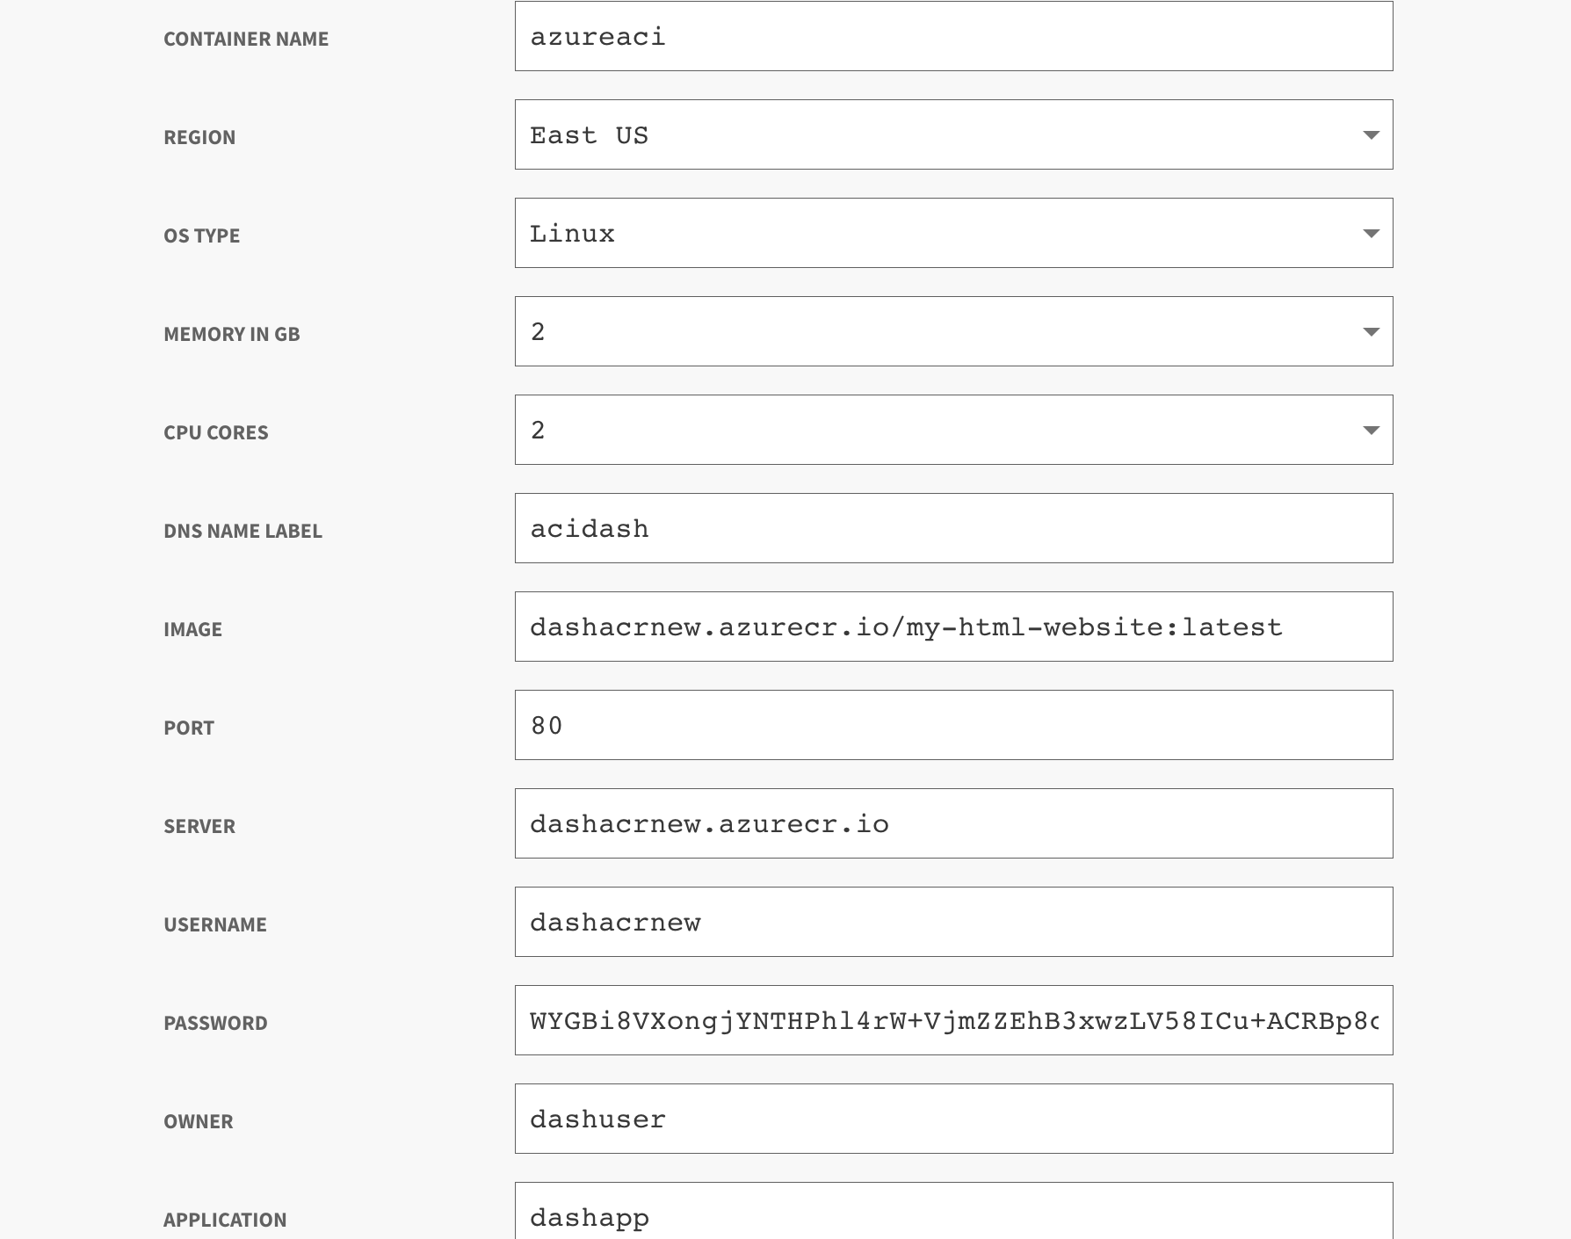

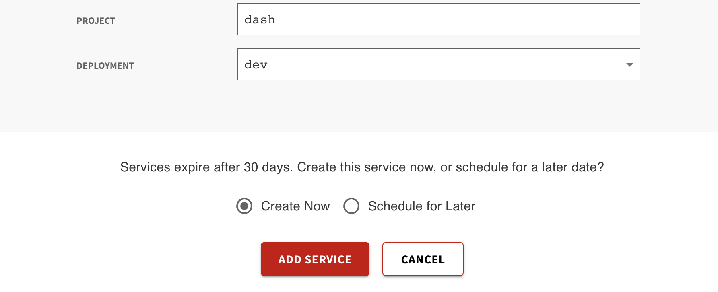

Output Guide
This section outlines the output values generated after provisioning an Azure Container Instance through the DASH Portal. These outputs can be used to access, manage, and connect to your virtual machine.
Name | Description | Example Value
container_group_fqdn | The Fully Qualified Domain Name (FQDN) of the Azure Container Group, accessible over the internet | newdemo.eastus.azurecontainer.io
container_ipv4_address | The public IPv4 address assigned to the Azure Container Group | 52.226.98.112

What You Can Do with These Outputs
Follow the steps below to access and verify your Azure Container Instance deployment. Replace any placeholders like <container_group_fqdn> with actual values from the outputs provided after provisioning.
Access the Application URL
Open your browser and go to:
http://<container_group_fqdn>
Example:
http://newdemo.eastus.azurecontainer.io
- This is the public DNS address of your container instance.

